What was missing in CPLDs that created a need for devices like FPGAs ?

**1 / 1 point**



Designs that required many flip-flops



Designs that contained large amounts of sequential circuits



All of the above

**Correct**

Completely correct.

**2.**

Question 2

Which of the following characterize FPGAs ? (**Select all that apply**)

**0.6666666666666666 / 1 point**



LUTs

**Correct**

Correct, FPGAs use LUTs to implement logic.



Scales easily to larger devices

**Correct**

Correct, FPGAs scale to larger designs better than CPLDs



Predictable

**This should not be selected**

CPLDs have more predictable timing than FPGAs



Rich with FFs/registers

**Correct**

Correct, FPGAs have higher density of registers than CPLDS.



Easy to design with



Deterministic

**This should not be selected**

FPGAs do not have deterministic timing relative to CPLDs or fixed logic, as the routing delays can vary in each design iteration.

**3.**

Question 3

Evaluate a, b, c, d & e in the table given below for the following :

**F = (A & ~B ) | (C & ~D)**

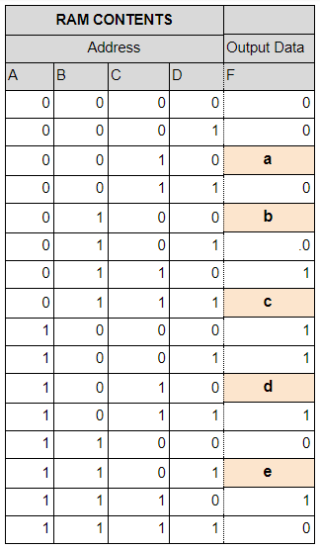

a = __

b = __

c = __

d = __

e = __

Enter your numerical answers separated by a comma

(example: ***x,x,x,x,x***or **1,1,1,1,1**)

**1 / 1 point**

1,0,0,1,0

**Correct**

**4.**

Question 4

Which of the following characteristics best match an **ASIC** and which of the following match an **ASSP** device?

**1 / 1 point**



***ASIC***: is a semiconductor device integrated circuit (IC) product that is dedicated to a specific company

***ASSP***: PLD with a fixed OR plane and a programmable AND plane



***ASIC***: is a semiconductor device integrated circuit (IC) product that is dedicated to a specific company

***ASSP***: Is a semiconductor device integrated circuit (IC) product that is dedicated to a specific application market and sold to more than one user



***ASIC***: PLDs that are an integrated circuit designed to be configured by the designer after manufacturing and made up of memory elements (LUTs)

***ASSP***: Is a semiconductor device integrated circuit (IC) product that is dedicated to a specific application market and sold to more than one user



***ASIC***: PLD with a fixed AND plane and a programmable OR plane

***ASSP***: Is a semiconductor device integrated circuit (IC) product that is dedicated to a specific application market and sold to more than one user

**Correct**

Correct for both.

**5.**

Question 5

Which of the following set of characteristics best matches **LUTs**.

**0 / 1 point**



PLDs with a fixed OR plane and a programmable AND plane



PLDs with a fixed AND plane and a programmable OR plane



Memory elements that are the basic elements of the device



PLDs with multiple PALs in the same package with registered outputs and an interconnecting programmable fabric



Is a semiconductor device integrated circuit (IC) product that is dedicated to a specific application market and sold to more than one user



Is a semiconductor device integrated circuit (IC) product that is dedicated to a specific company



PLDs that are an integrated circuit designed to be configured by the designer after manufacturing and made up of memory elements (LUTs)

**Incorrect**

A Look-up table usually a portion of a device, not the entire device.

**6.**

Question 6

Which of the following is the best definition for a **CPLD ?**

**0 / 1 point**



A device with multiple PALs in same package with registered outputs and interconnecting programmable fabric



A device with a combination of fully re-programmable AND/OR array and a bank of macrocells that perform combinational and sequential logic



An array of programmable logic blocks, and a hierarchy of reconfigurable interconnects that allow the blocks to be "wired together", like many logic gates that can be inter-wired in different configurations

**Incorrect**

OR arrays are not usually reprogrammable in CPLDs

**7.**

Question 7

Which of the following characteristics are associated with **SRAM FPGAs** ?

(**Select all that apply** )

**0.16666666666666666 / 1 point**



High Reliability

**This should not be selected**

SRAM FPGAs have reliability issues with SEUs that must be mitigated



Highest Density



Reprogrammable



Expensive

**This should not be selected**

SRAM FPGAs are not expensive



One time Programmable (OTP)

**This should not be selected**



Lowest Cost

**Correct**

Correct, SRAM FPGAs have lower cost due to the process advantages and higher logic density.

**8.**

Question 8

How many**4-input LUTs** with single outputs will be required to implement a **2-bit full adder**with carry?

**0 / 1 point**



2



4



1



3

**Incorrect**

Sorry, more LUTs are required to create an intermediate carry

**9.**

Question 9

Does the usage of LUTS for implementation of adders with respect to gates improve delay or performance? Select all that apply..

**1 / 1 point**



decreases delay

**Correct**

True, as the number of gate delays will be larger than the number of LUT delays. The result of the implementation of the 4-bit ripple-carry adder in the Altera MAX10 FPGA is made of a cascade of 4 pairs of 3-input LUTs. The delay through this circuit will be only 4 LUT delays, not 11 gate delays as based on the delay equation of Carry Look ahead adder.



increases delay



increases performance

**Correct**

This is also correct



decreases performance

**10.**

Question 10

Which of the characteristics describe the implementation of a multiplier in an FPGA using Hard Multipliers versus implementation in Memories ? (**Mark all that apply**)

**0.75 / 1 point**



**Hard Multipliers**: Fast



**Hard Multipliers**: Slow



**Memories**: Do not scale easily , Lookup Tables

**Correct**

Correct. Multipliers built of memory do not scale easily as the memory size of the look- up table grows exponentially.



**Memories**: Complex , Lookup Tables

You didn’t select all the correct answers

**11.**

Question 11

Which of the characteristics match the implementation of a multiplier in an FPGA using Speciality Circuits, such as the Booth Algorithm ? ( **Mark all that apply )**

**0.75 / 1 point**



Fast

**Correct**

Correct, Booth Algorithm multipliers are fairly fast in execution time



Big



Small

**Correct**

Correct. Booth algorithm multipliers are fairly small in area especially for larger multiplicands



Slow



Complex

**Correct**

Correct. Booth algorithm multipliers are more complex than shifter or memory types



Do not scale easily

**This should not be selected**

Booth algorithm multipliers scale fairly well are numbers get larger



Lookup Tables

**This should not be selected**

Booth algorithm multipliers use shift registers and adders, no lookup tables



State Machine

**Correct**

Correct. Booth algorithm multipliers can be implemented using a state machine.

**12.**

Question 12

Which one of the following is **not** a programmable logic device?

**1 / 1 point**



EPROM



PLA



CPLD



ROM



FPGA

**Correct**

Correct. A ROM’s bit pattern is set during manufacturing of IC and can’t be changed.

**13.**

Question 13

What is true for ASICs relative to FPGAs? (Select all that may apply)

**0.5 / 1 point**



High cost per unit

**This should not be selected**

This is incorrect



ASICs have lower cost per unit.



Lower speed



Higher speeds

**Correct**

Correct. ASICs generally have higher speed than FPGAs

**14.**

Question 14

What are the principal advantages of FLASH based FPGAs over SRAM based FPGAs ? (**Mark all that apply**)

**0.25 / 1 point**



Faster Speed

**This should not be selected**

FLASH FPGAs are generally slower than SRAM FPGAs



Lower Power



Higher Reliability

**Correct**

Correct. FLASH FPGAs are more reliable, with SEU immunity



Better Security

**15.**

Question 15

Which of the following is the best implementation for a 2-bit full adder. Hint: make sure to pay attention to signal names as well as circuit diagram.

**1 / 1 point**



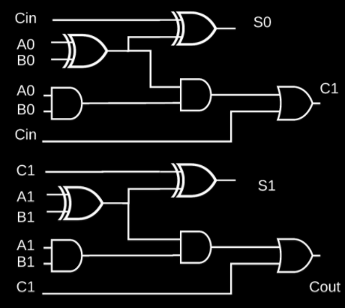

.



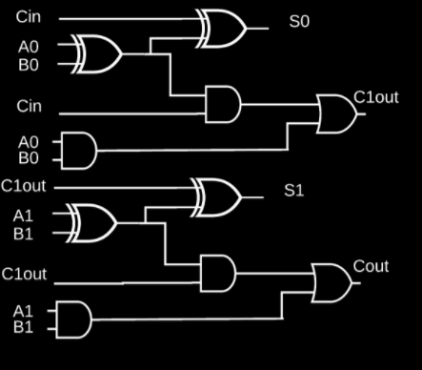

.



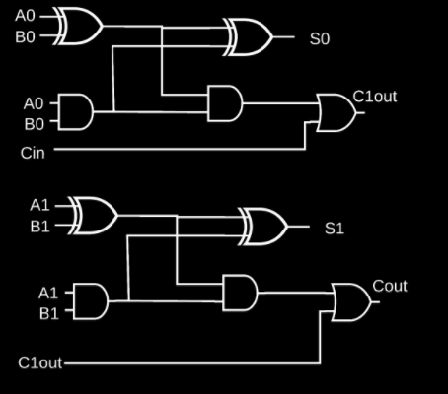

.

**Correct**

**16.**

Question 16

**Choose the best implementation of the logic equation**

**((A) AND (B)) OR (NOT(C) AND NOT(D))**

**using PLA options:**

**1 / 1 point**



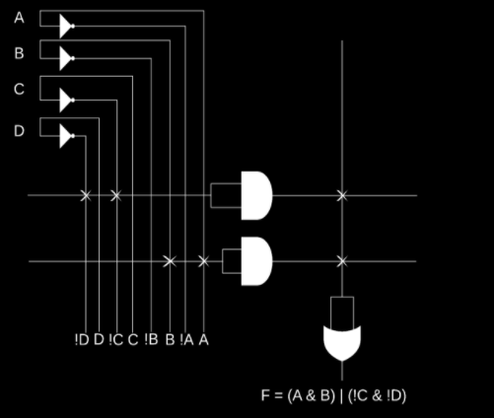

.



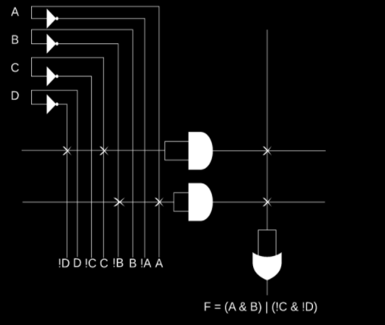

.



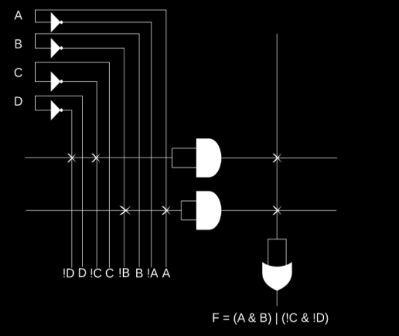

.



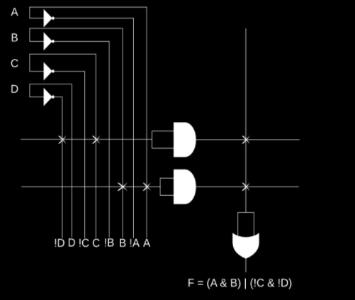

.

**Correct**

**17.**

Question 17

**Choose the correct implementation of logic equation**

**((A) AND (C)) OR (NOT(B) AND D)**

**using PLA options:**

**0 / 1 point**



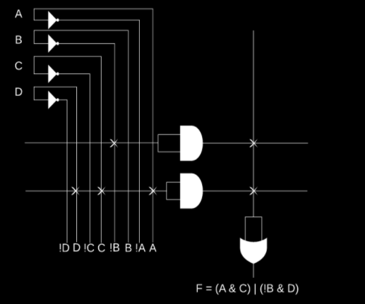

.



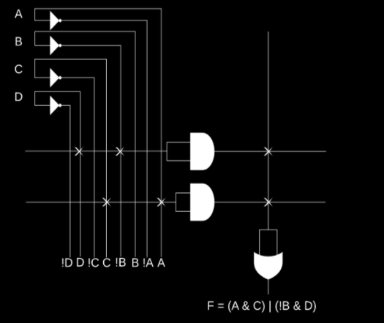

.



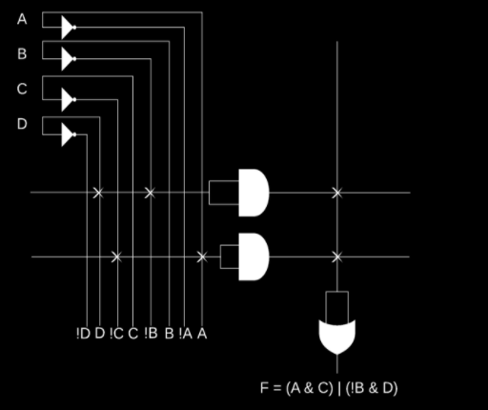

.



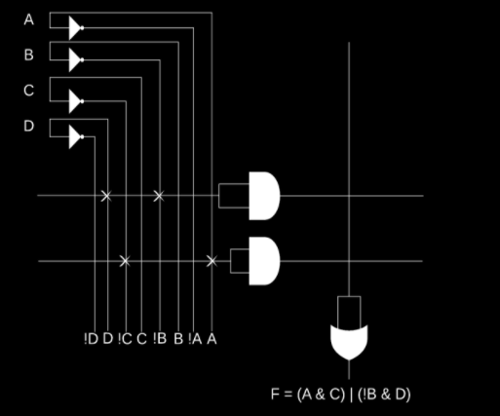

.

**Incorrect**

If you missed this, you might want to review Video 5